ICS344
Project
Hassan Alhassan
Lesson-7

Lesson #7: Over Privileged Function
Part 1) Goal and Vulnerability Summary
This lesson (7- Over-Privileged Function) demonstrates that a Lambda execution role can grant far more AWS permissions than a function actually needs. In serverless systems, this dramatically increases blast radius whenever code execution or abuse becomes possible. For example, S3 could be abused where attacker could add, delete and etc…

Part 2) Why This Works / Root Cause
The weakness in this lesson is not the business logic of the function itself, but the excessive IAM permissions attached to its execution role. In AWS serverless systems, any code running inside a Lambda function automatically inherits the role’s temporary credentials. As a result, if the function is abused or compromised, the attacker can perform any AWS action allowed by that role, even if those actions are unrelated to the function’s intended purpose. The root cause is therefore over-privileged role design and failure to enforce least privilege

Part 3) Environment and Setup

Step 1: Locate the Lambda Function
- Open the AWS Management Console.
- Navigate to AWS Lambda service.
- From the left-hand menu, click on “Functions”.
- In the search bar, enter:
DVSA-SEND-RECEIPT-EMAIL
- Select the corresponding Lambda function from the results.

Step 2: Access the Function Configuration
- Open the selected Lambda function page.
- Go to the Configuration tab.
- In the left-side panel, click on Permissions.

Step 3: View the Execution Role
- Under the Execution role section, locate the role name.
- Click on the execution role name to open it in the IAM console.
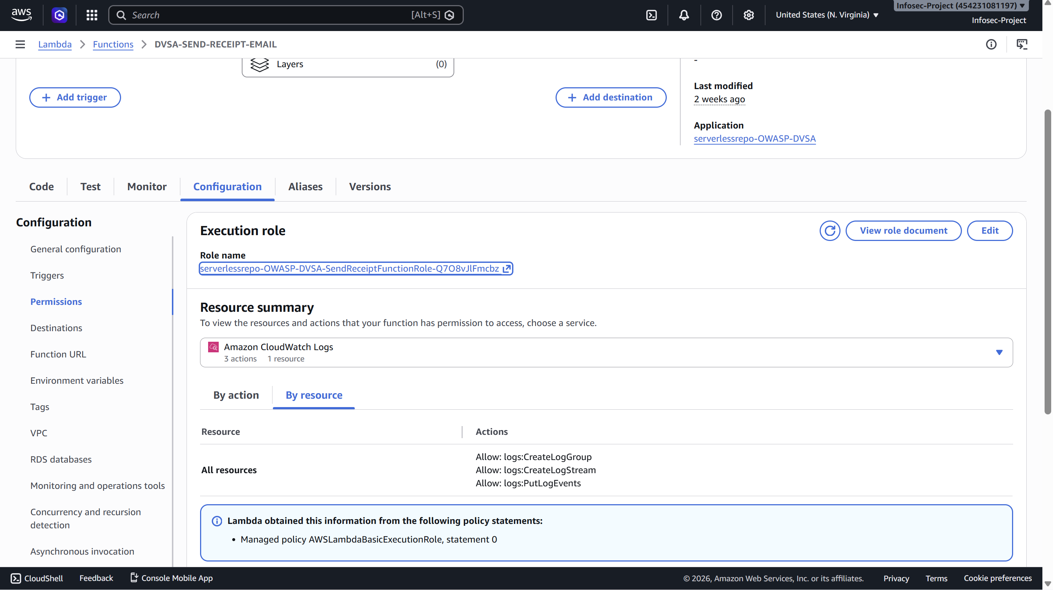

Other Used Services You May Open:
- Cloud Shell: Used for performing the attack.
- CloudTrail: Used for generating the policy.
- CloudWatch: Used for seeing the output of triggering the function.

Part 4) Reproduction Steps
Step 1: Open IAM Role Policies
- Navigate to the IAM Role page accessed from the Lambda execution role.
- Go to the Permissions tab.
- Review all attached policies associated with the role.

Step 2: Identify Attached Policies
Check for the following typical policies attached to the role:
- AWSLambdaBasicExecutionRole
- AmazonSESFullAccess
- SendReceiptFunctionRolePolicy1 (S3 access)
- SendReceiptFunctionRolePolicy2 (DynamoDB access)
- SendReceiptFunctionRolePolicy3 (STS GetCallerIdentity)

Step 3: Analyze for Over-Privilege Issues
While reviewing the policies, identify potential over-privilege patterns such as:
S3 Over-Permission
- Wildcard resource access applied to all buckets or objects:
  - arn:aws:s3:::*
  - arn:aws:s3:::*/*

DynamoDB Over-Permission (High Blast Radius)
- Table-wide access instead of specific table restriction:
  - arn:aws:dynamodb:REGION:ACCOUNT:table/*
- Use of index-level wildcards or unrestricted access patterns

SES Over-Permission
- Unrestricted email service access such as:
  - AmazonSESFullAccess

Step 4: Document Findings
Record any policies that violate the principle of least privilege, especially where:
- Access is granted to all resources (*)
- Permissions are broader than required by function logic
- Sensitive services (S3, DynamoDB, SES) are fully open without restriction
Step 5: After Seeing the privileges, lets perform the attack:
- Go to DVSA-SEND-RECEIPT-EMAIL function to insert both print statements:
  - Print("The credentials are: ")
  - Print(dcit(os.environ))
- Go to cloudshell to run the two commands:
  - touch ~/empty
  - aws s3 cp ~/empty s3://dvsa-receipts-bucket-454231081197-us-east-1/2020/20/20/trigger.raw
- After trigging the lambda function using the command, go to view CloudWatch under Monitor to harvest the credentials.
- Click on the record that invoked the function.
- Harvest the credentials by using:
  - export AWS_ACCESS_KEY_ID=""
  - export AWS_SECRET_ACCESS_KEY=""
  - AWS_SESSION_TOKEN=""
- Verify that you are like the function:
  - aws sts get-caller-identity
- Run the command to scan the DB:
  - aws dynamodb scan \ --table-name DVSA-ORDERS-DB \ --region us-east-1

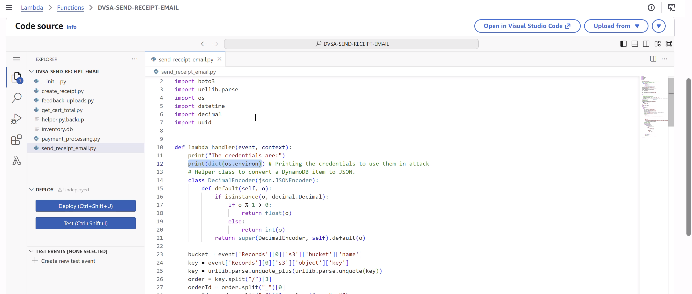
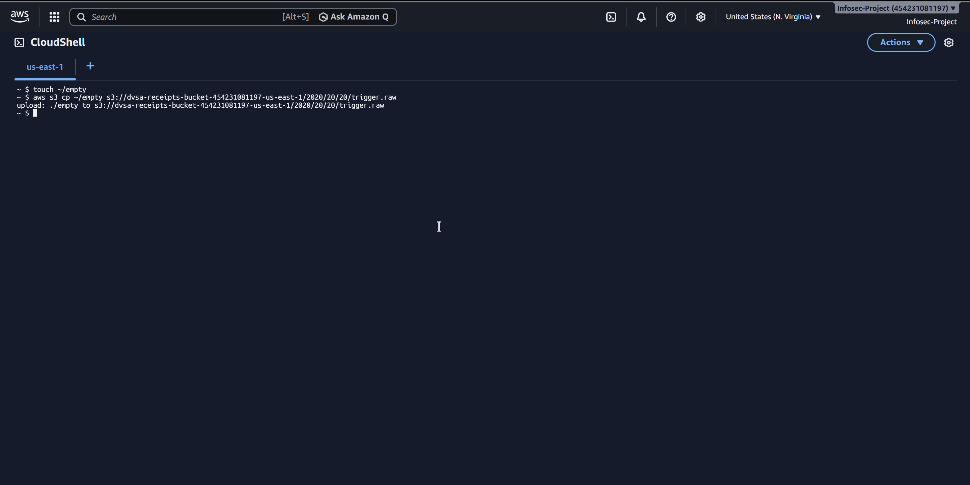
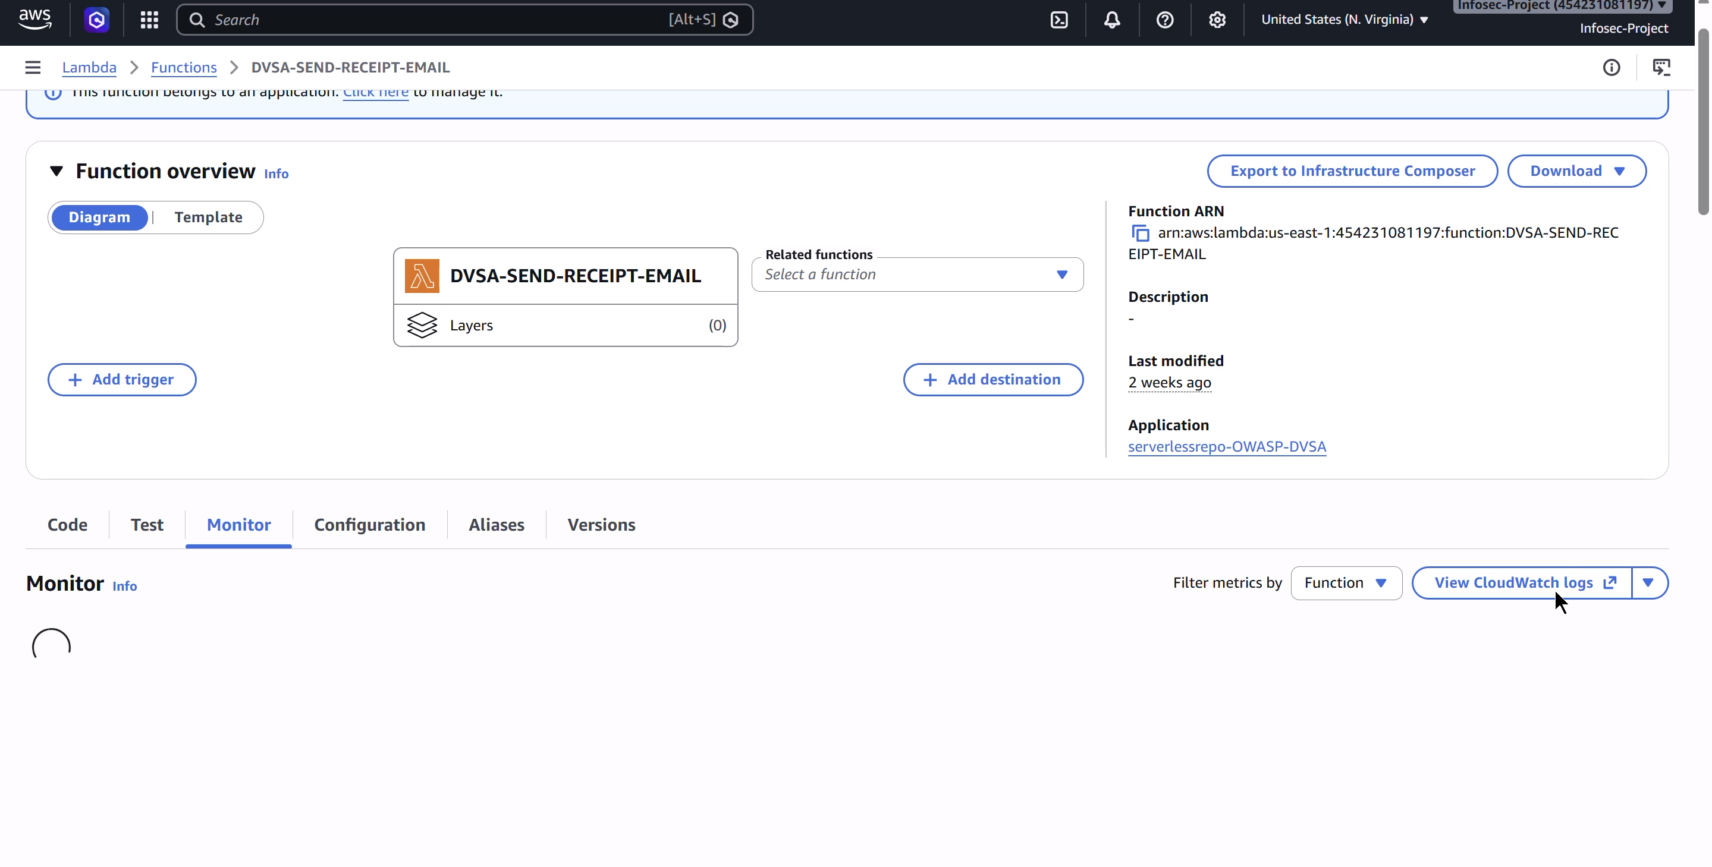
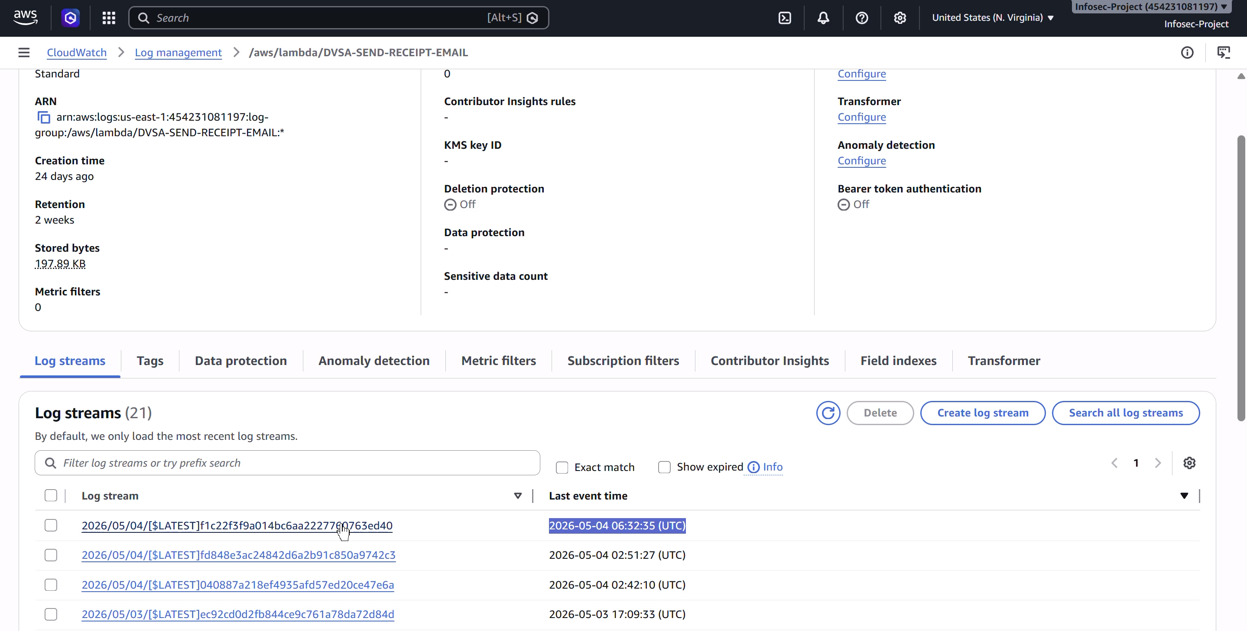
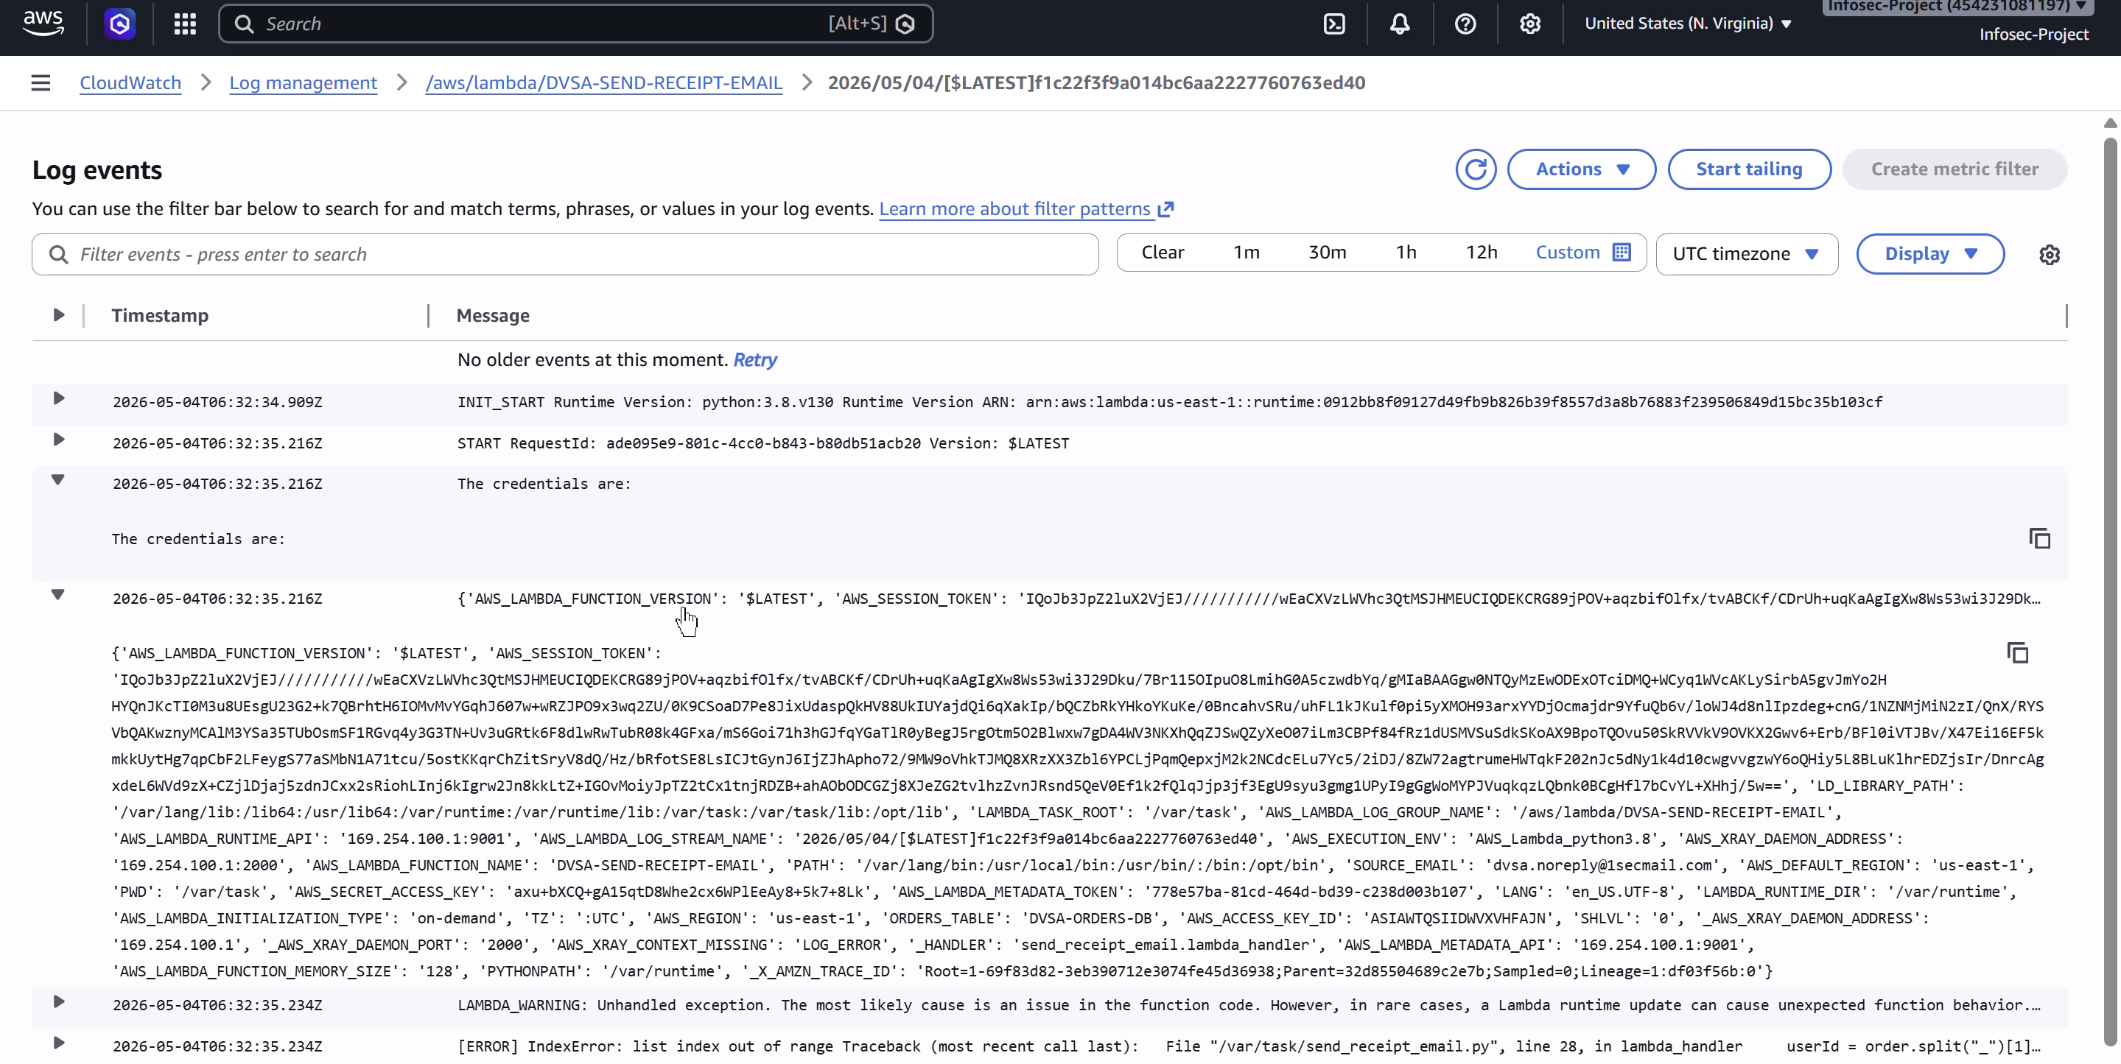
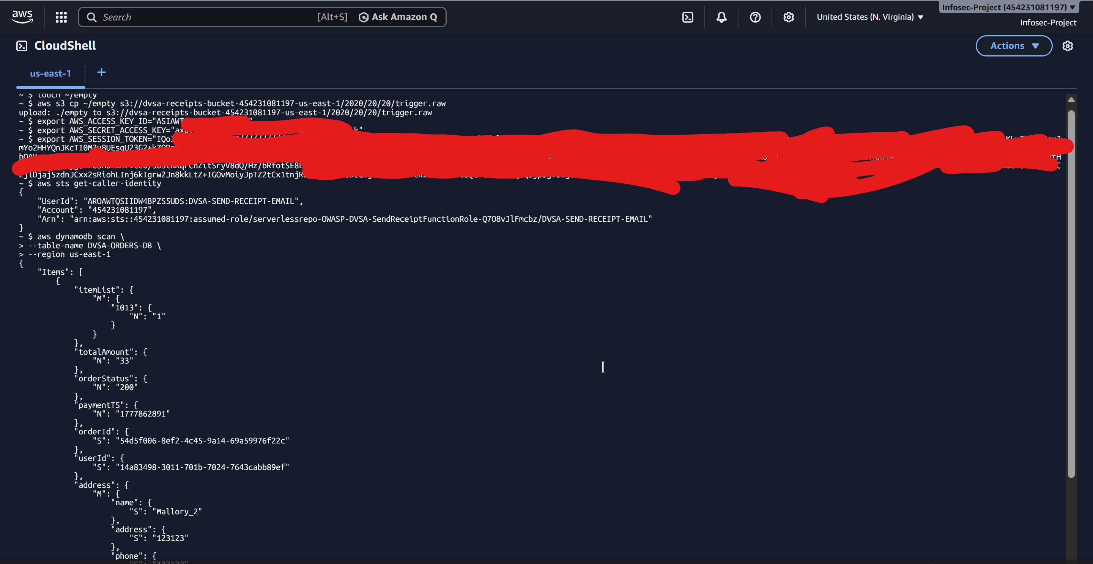

Part 5) Evidence and Proof
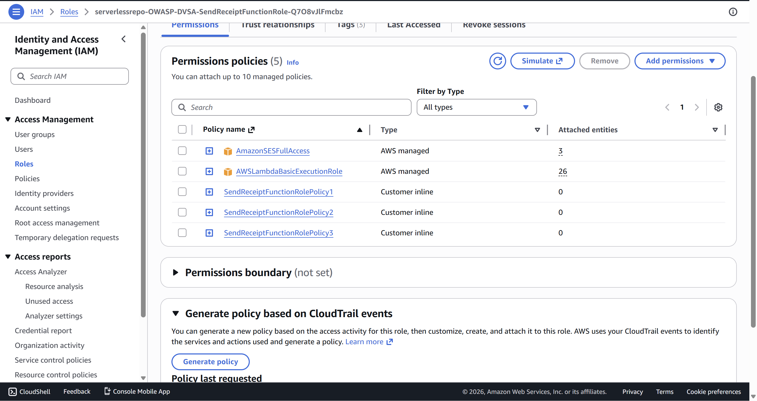
At this stage, we establish the following hypothesis:
“The Lambda execution role has significantly more permissions than required for its intended functionality.”
We will validate this using the IAM Policy Simulator.

Step 1: Open IAM Policy Simulator
- Navigate to the AWS IAM Console.
- In the main dashboard, locate the Tools section.
- Open Policy Simulator.

Step 2: Select the Execution Role
- In the IAM Policy Simulator interface, locate the left panel.
- Change the Identity Type from Users to Roles.
- Search and select the receipt function execution role:
serverlessrepo-OWASP-DVSA-SendReceiptFunctionRole-...

Step 3: S3 Permission Blast-Radius Testing
- On the right panel, select the service: Amazon S3.
- Add the following actions:
  - GetObject
  - PutObject
- Click Run Simulation.
- For each action, test against a sample resource ARN such as:
arn:aws:s3:::some-bucket/some-key
- Observe the results:
  - s3:GetObject → Allowed
  - s3:PutObject → Allowed
Interpretation:
These results indicate that the role may access objects across S3 resources, which exceeds the expected permissions required for a simple “send receipt” function.
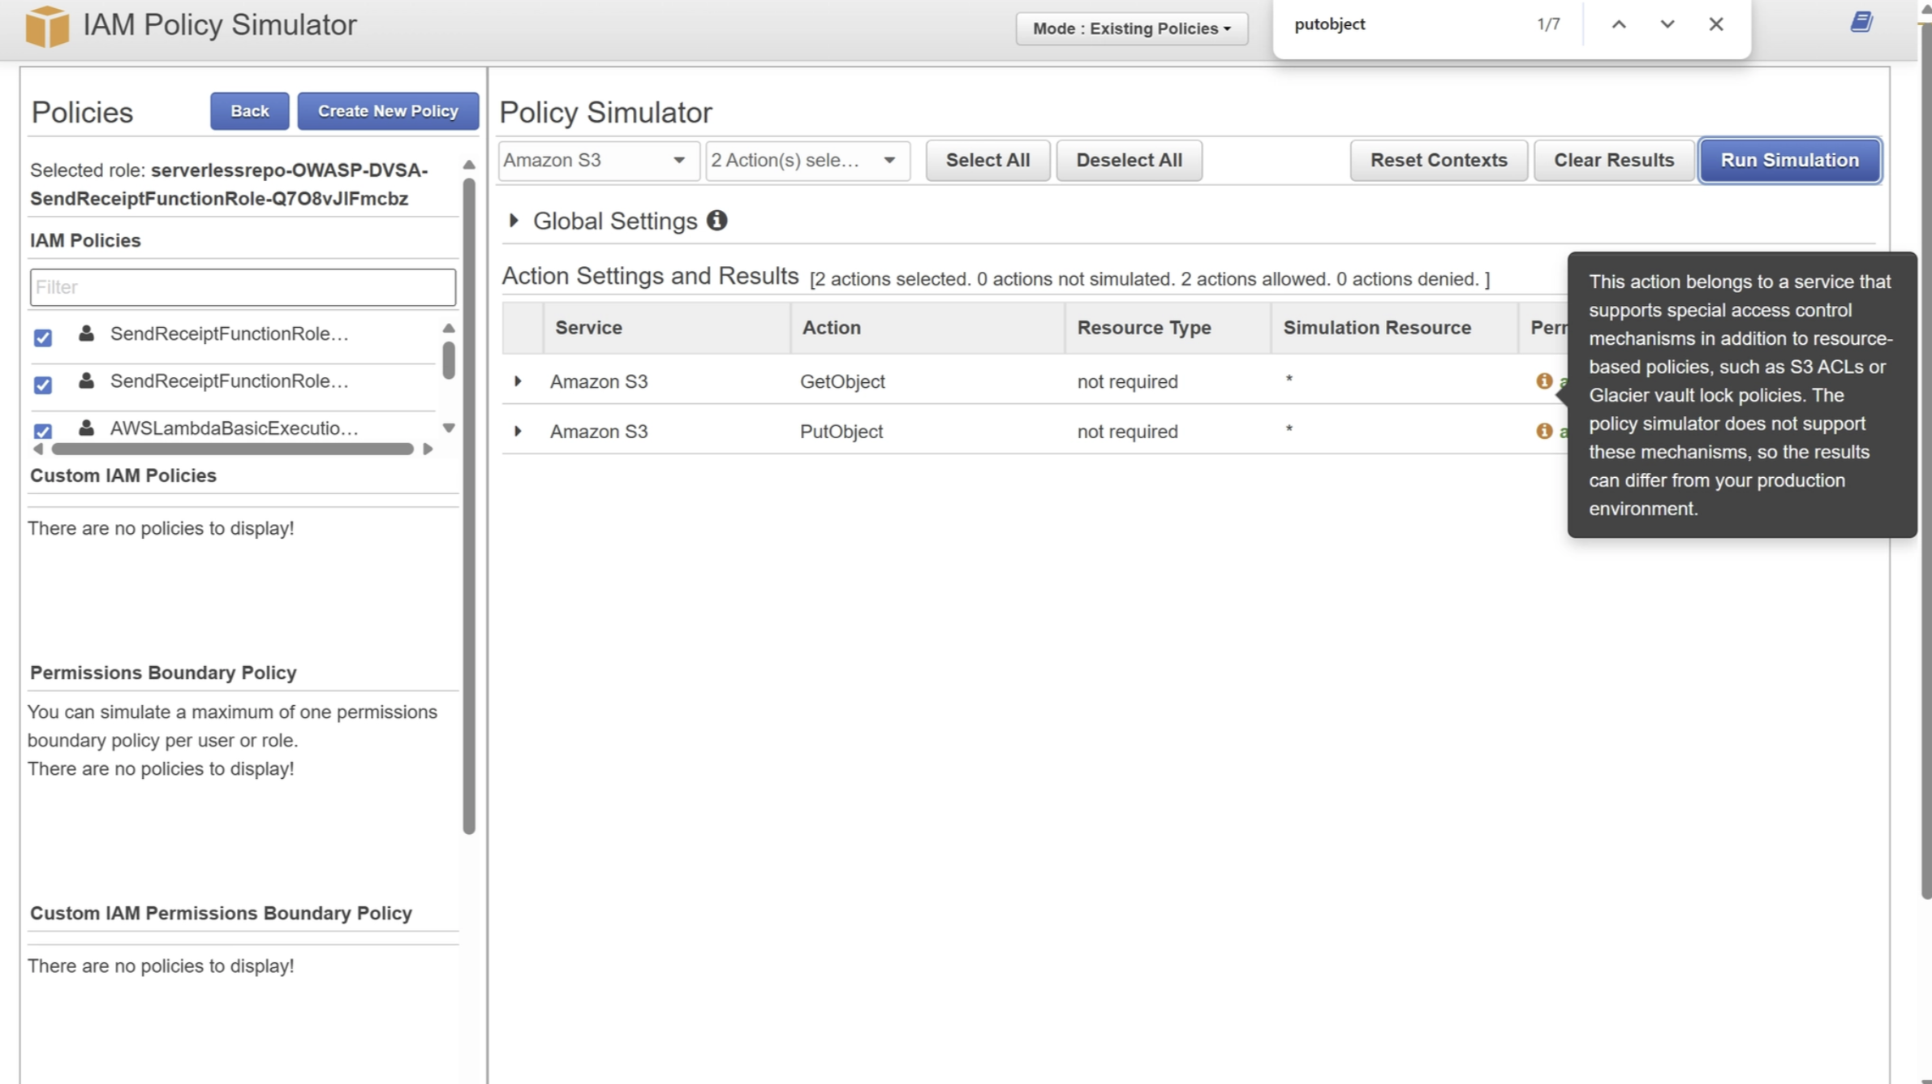

Step 4: DynamoDB Permission Blast-Radius Testing
- In the simulator, select the service: Amazon DynamoDB.
- Add the following actions:
  - Scan
  - GetItem
  - PutItem
  - DeleteItem
- Run the simulation using a test resource ARN such as:
arn:aws:dynamodb:us-east-1:<ACCOUNT_ID>:table/some-table
- Observe the results:
  - dynamodb:Scan → Allowed
  - dynamodb:GetItem → Allowed
  - dynamodb:PutItem → Allowed
  - dynamodb:DeleteItem → Allowed
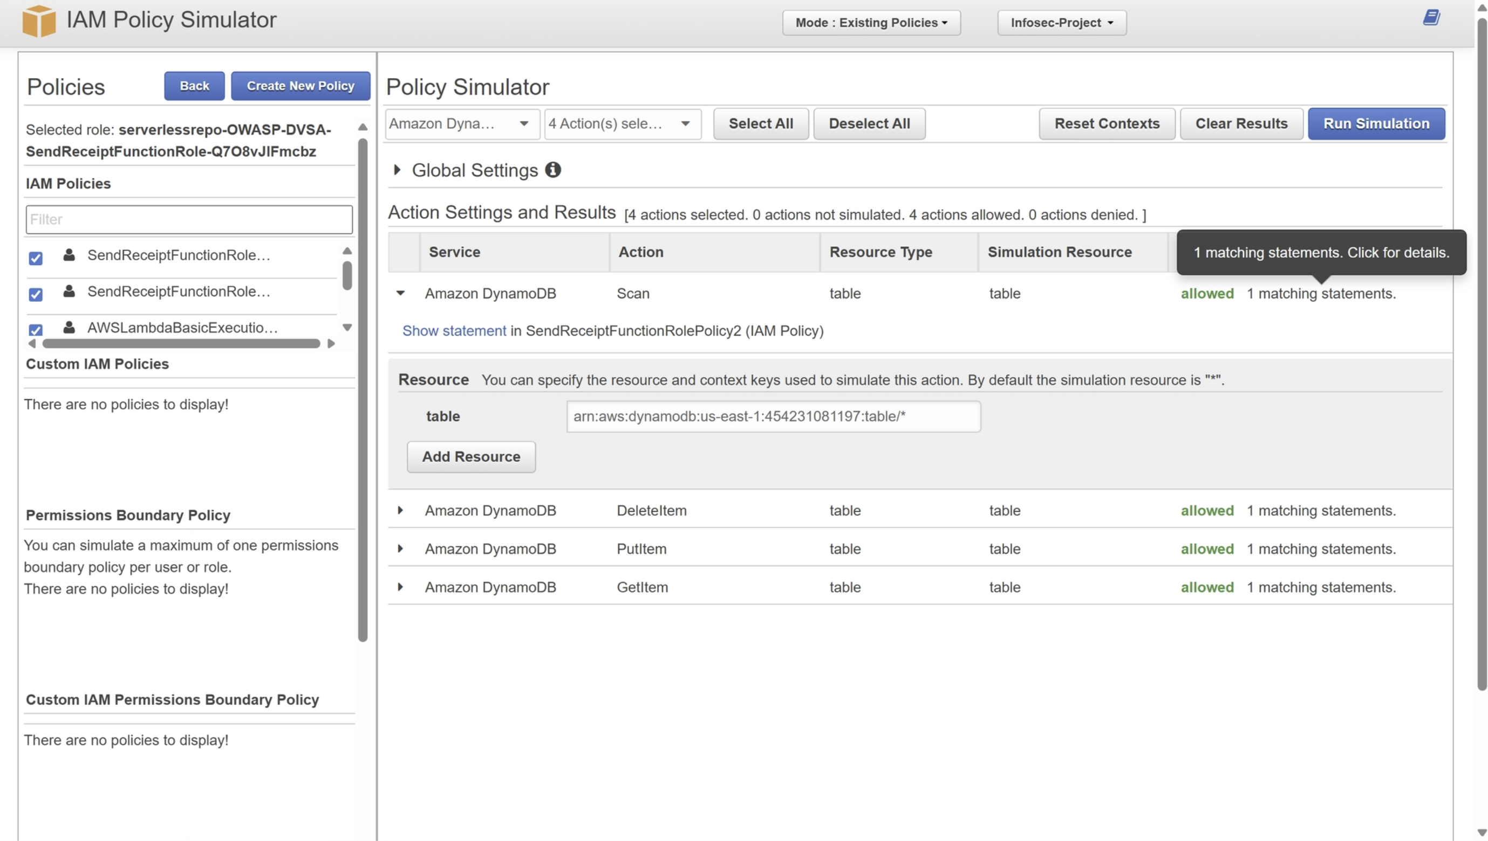

Step 5: Interpretation of Results
The simulation demonstrates that the execution role has broad permissions across DynamoDB tables within the account and region.
This implies:
- The Lambda function can read, modify, and delete data from any DynamoDB table, not only DVSA-related tables.
- The granted permissions exceed the principle of least privilege.
- The potential blast radius is significantly larger than required for the function’s intended behavior.

Continued Part 5) Evidence and Proof (CloudTrail-Based Verification of Actual Usage)
To strengthen our hypothesis about over-privileged permissions, we now verify what the Lambda function actually uses in runtime using AWS CloudTrail.

Step 5: Enable AWS CloudTrail
- Navigate to the AWS CloudTrail service.
- Go to Trails in the left-hand menu.
- Click Create trail.
- Configure the trail with the following settings:
- Trail name: dvsa-policygen-trail
- Multi-region trail: Enabled (Yes)
- Management events: Enabled (On)
- Data events: Disabled (Off)
- Storage: Allow AWS to automatically create the S3 log bucket
- Confirm that the trail status changes to:
Logging

Also, here is a successful attempt of the scan attack:

Running the command shows the contents of the DB:
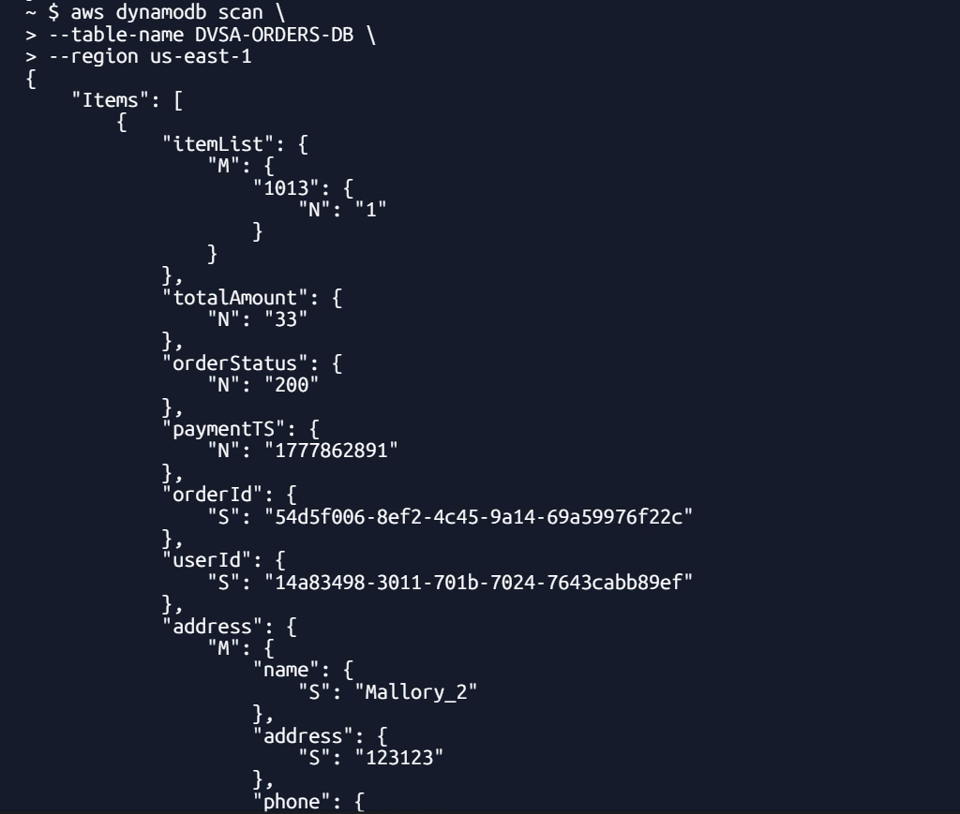

Step 6: Trigger the Lambda Function
To generate real CloudTrail activity:
- Return to the DVSA application.
- Perform the relevant workflow that triggers the receipt email (place an order and complete a transaction).
- Confirm Lambda execution:
- Go to AWS Lambda → Functions
- Open: DVSA-SEND-RECEIPT-EMAIL
- Navigate to the Monitor tab
- Open CloudWatch Logs
- Verify that a new invocation log entry has been created
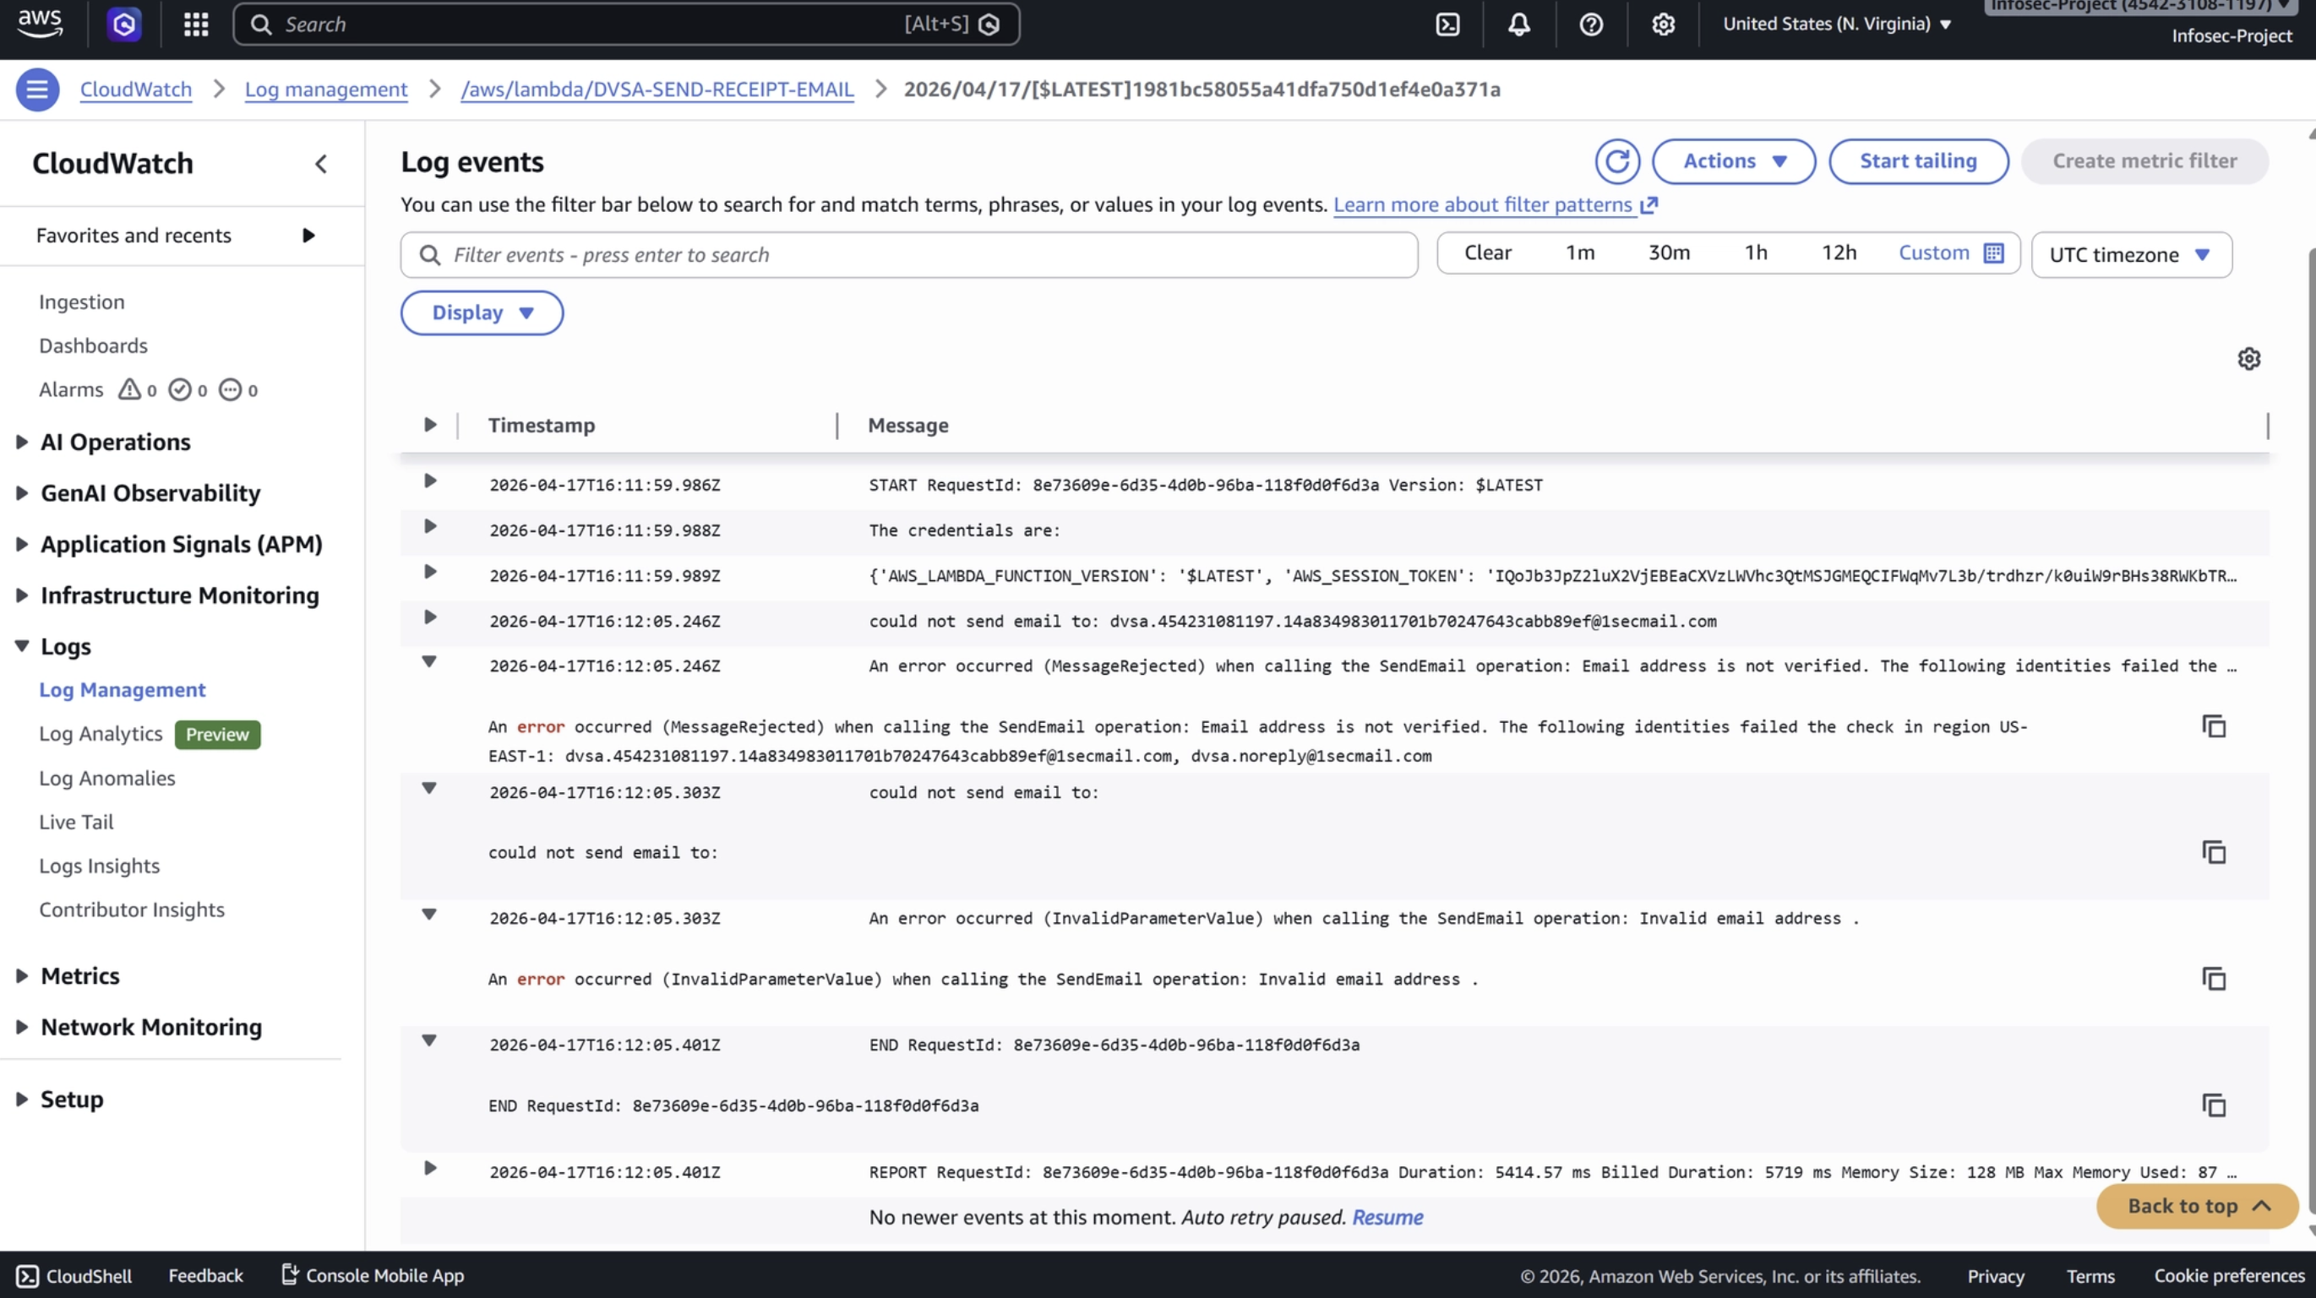

Step 7: Generate Policy from Observed Activity
- Navigate to AWS IAM → Roles.
- Open the execution role:
serverlessrepo-OWASP-DVSA-SendReceiptFunctionRole-...
- Select the option Generate policy (or access it from the role actions menu).
- Configure the following:
- Time period: Last 1 day
- Region: us-east-1 (N. Virginia)
- Trail: dvsa-policygen-trail
- Click Generate policy.

Step 8: Review Observed (Actually Used) Permissions
On the generated policy review page, AWS lists the permissions detected from CloudTrail based on actual function execution.
After triggering the receipt workflow, the observed permissions were:
- CloudWatch Logs: CreateLogStream
- AWS KMS: Decrypt
- AWS STS: GetCallerIdentity

Step 9: Interpretation of Results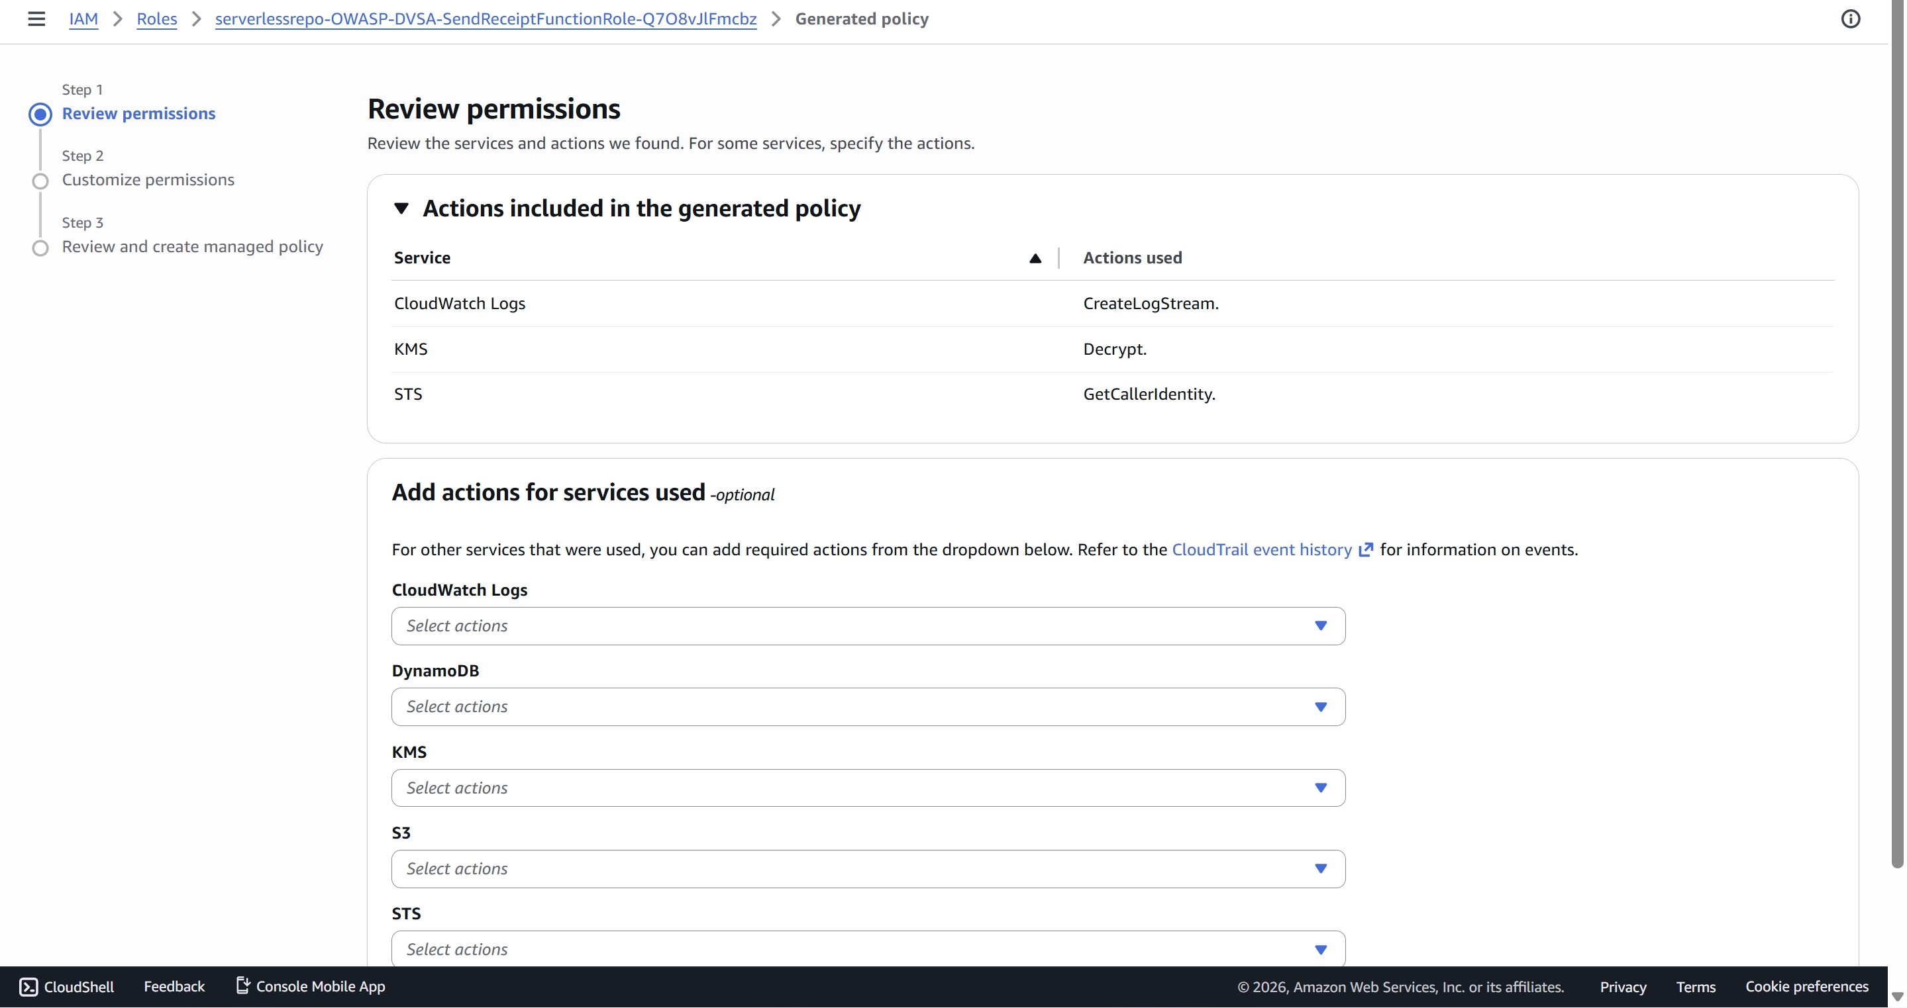
The generated policy shows the real runtime behavior of the Lambda function.
This reveals that:
- The function uses only a small subset of permissions in practice.
- Many attached IAM permissions (e.g., S3 full access, DynamoDB full access, SES full access) are not observed in actual execution traces.
- This confirms a clear over-privilege gap between:
  - Declared permissions (IAM policy)
  - Actual used permissions (CloudTrail logs)

Part 6) Fix Strategy / Probable Mitigation
The fix simply belong to the IAM service where we should reduce the given roles to the function to as minimum as possible achieving the least-privilege policies. By reducing the privileges, attacker could no longer abuse them beyond the intended purpose of function.

Part 7) Code / Config Changes
Restricted the previliges of S3 and DynomoDB so that it cannot be exploited beyond its intended functionalities:
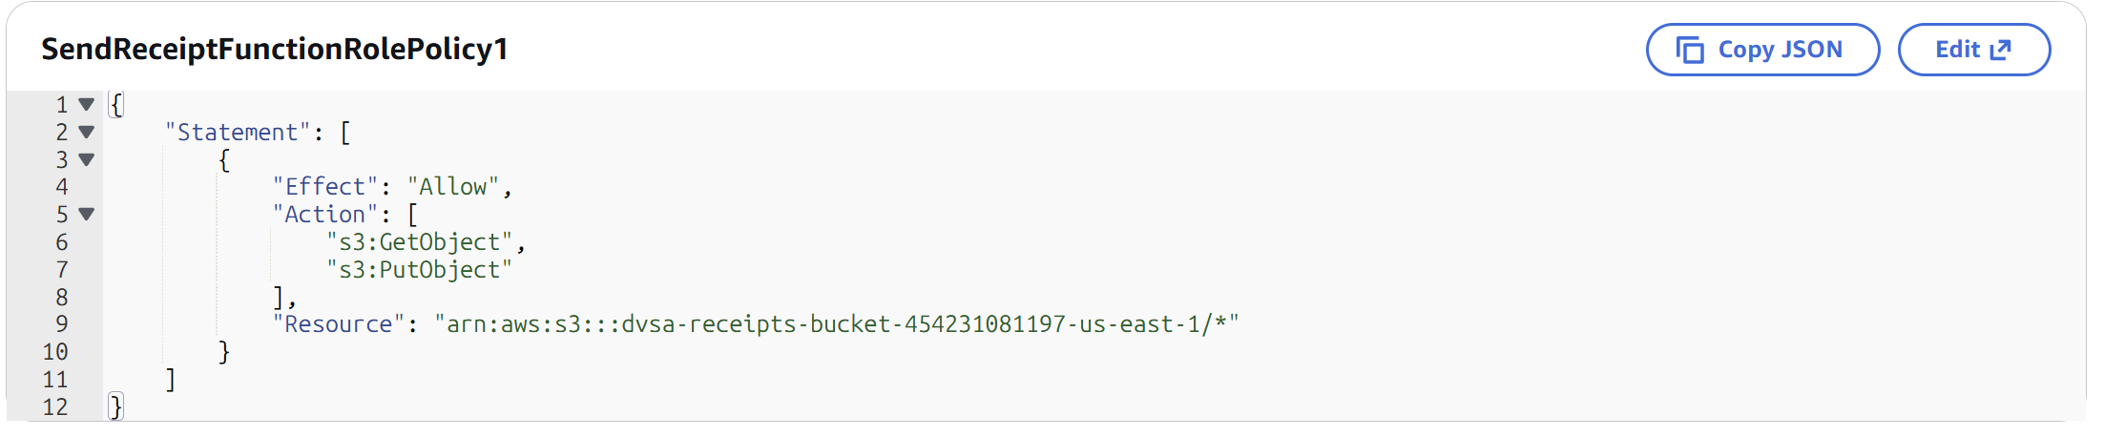
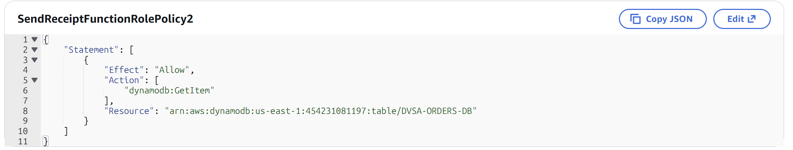
Also, removed the AmzonSESFullAccess that grants every email service and replaced it with send email service only:
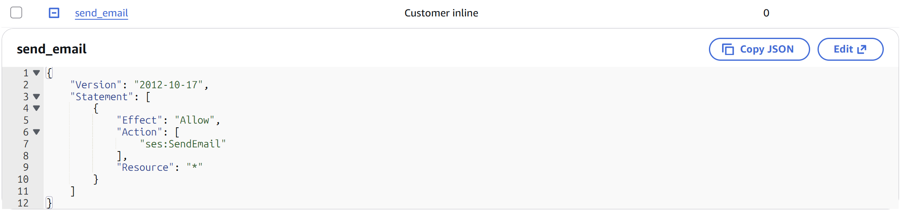
We did this fix because S3 and DynamoDB although they haven’t appear in CloudTrail, they are used in the code:
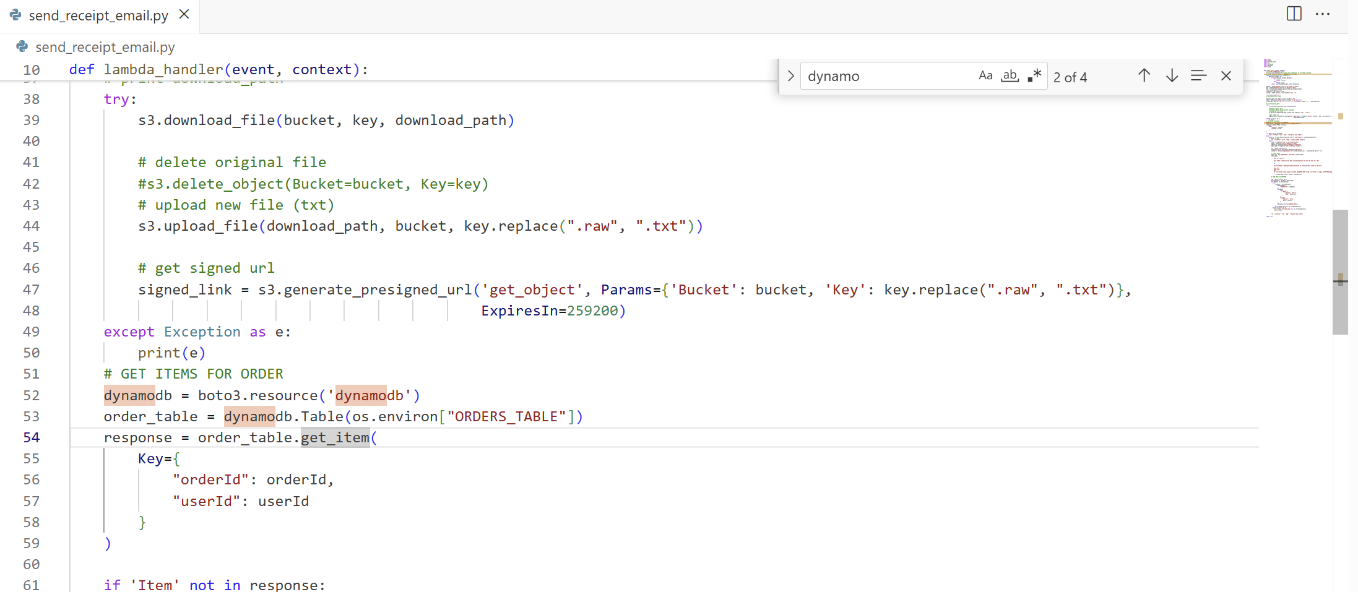

Part 8) Verification After Fix
Now, after restricting the privileges, the attacker no longer could do the scan command and others using the CLI:

Part 9) Structured Operation and Security Analysis
1. Intended Logic and Security Rule(s)
The DVSA-SEND-RECEIPT-EMAIL Lambda is triggered after a successful order to send a confirmation email via SES. The main actor is the Lambda runtime, authenticated automatically via its IAM execution role. The AWS services legitimately needed by the function are: S3 (s3:GetObject and s3:PutObject scoped to the receipt bucket — to download the raw file and upload the processed .txt receipt),DynamoDB (dynamodb:GetItem), SES (ses:SendEmail scoped to the verified sender — to email the customer), STS (sts:GetCallerIdentity — to construct the secmail address), CloudWatch Logs and KMS (for execution logging). The role should grant exactly these permissions against specific resource ARNs — nothing more.
Security Rules:
- A Lambda execution role must grant only the minimum permissions required for the function's stated business logic (principle of least privilege).
- Wildcard resource ARNs (*) must never be used in production IAM policies when specific resource ARNs are known.

2. Evidence Sources and Behavior Trace
Artifacts used: IAM role policy inspection (AWS Console), IAM Policy Simulator (simulated blast-radius actions), CloudTrail-generated least-privilege policy (actual runtime permissions), CloudWatch Logs (invocation records), CloudShell terminal output (credential harvesting and dynamodb:Scan execution).
Condition | Observed Behavior
Normal | Function triggers on S3 upload event → sends receipt email via SES → writes execution log to CloudWatch. CloudTrail records only: logs:CreateLogStream, kms:Decrypt, sts:GetCallerIdentity.
Exploit | Attacker injects print(dict(os.environ)) into the function code → triggers execution via aws s3 cp → harvests AWS_ACCESS_KEY_ID, AWS_SECRET_ACCESS_KEY, AWS_SESSION_TOKEN from CloudWatch → exports credentials → runs aws dynamodb scan --table-name DVSA-ORDERS-DB → full table contents returned. IAM Policy Simulator also confirms s3:GetObject, s3:PutObject, dynamodb:Scan, dynamodb:DeleteItem all Allowed against wildcard ARNs.
Post-fix | S3 resource ARN restricted to specific receipt bucket only. DynamoDB ARN restricted to specific table with GetItem only. AmazonSESFullAccess replaced with ses:SendEmail scoped to verified sender. Running dynamodb:Scan with harvested credentials now returns AccessDeniedException.

3. Deviation Analysis and Classification
The exploit violates the least-privilege rule because the role grants S3 and DynamoDB permissions that are structurally unrelated to sending a receipt email. The IAM Policy Simulator proves that the role can Scan, PutItem, and DeleteItem against any DynamoDB table, and read/write any S3 object in the account. The CloudTrail-generated policy proves that in actual runtime the function uses only three permissions — making the gap between declared and used permissions undeniable. The credential harvesting attack required no special access: any code injected into the Lambda function automatically inherits the full role, giving an attacker account-wide data access through a single compromised function.
Deviation Class: Accidental misconfiguration — over-broad managed policies and wildcard ARNs were attached for convenience and never scoped down before deployment.

4. Explainable Fix and Post-Fix Validation
Wrong assumption: That attaching broad managed policies like AmazonSESFullAccess and wildcard resource ARNs is harmless because the function "probably won't use" the extra permissions.
Where the fix belongs: IAM — the inline and managed policies attached to SendReceiptFunctionRole.
Exact changes:
- S3 policy: resource ARN restricted from arn:aws:s3:::*/* to the specific receipt bucket ARN only, with actions narrowed to GetItem and PutItem.
- DynamoDB policy: resource ARN restricted from arn:aws:dynamodb:REGION:ACCOUNT:table/* to the specific table, with actions narrowed to GetItem only.
- SES policy: AmazonSESFullAccess removed and replaced with a custom policy scoped to ses:SendEmail for the verified sender identity only.
Post-fix confirmation: Running aws dynamodb scan with the harvested credentials returns AccessDeniedException. The receipt email workflow continues to function correctly, confirming legitimate behavior is preserved.

Standard Summary Table Template

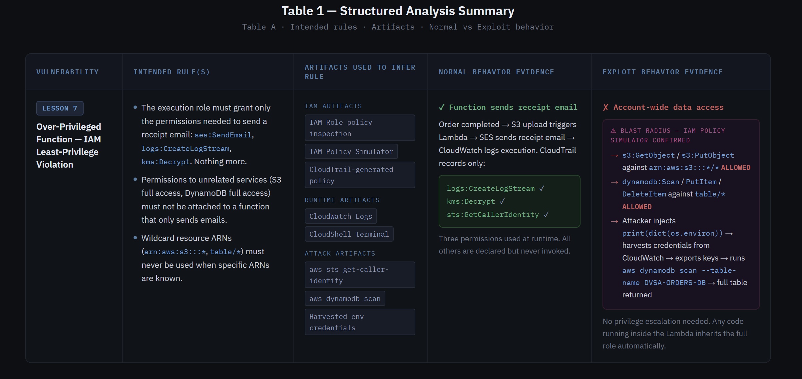
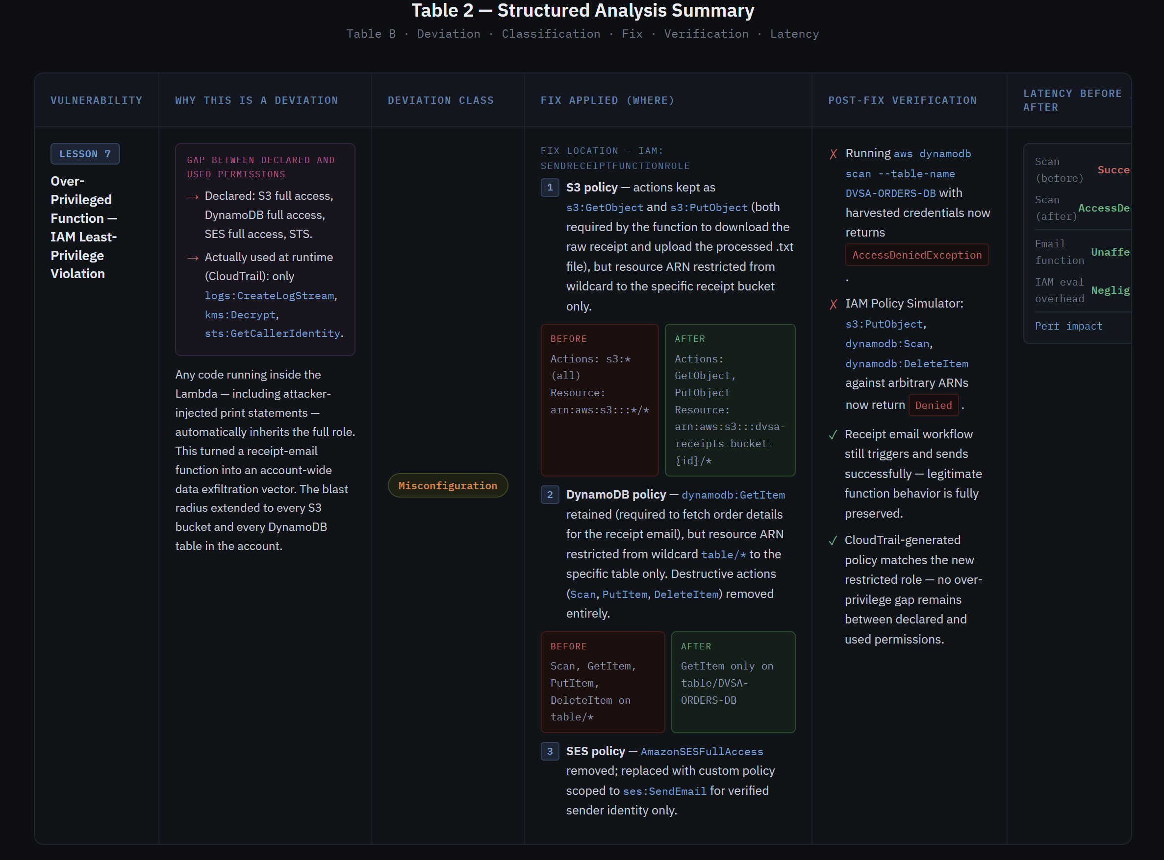

Part 10) Takeaway / Lessons Learned
The core flawed assumption was that attaching broad managed policies like AmazonSESFullAccess and wildcard ARNs is harmless as long as the function's own code never calls those extra services. This assumption fails completely once the attacker controls what code runs inside the function — whether through injection, a supply-chain compromise, or a misconfigured trigger. At that point, the function's code is irrelevant; the IAM role is the only access boundary that matters.
In a serverless environment this risk is structurally higher than in traditional systems. There is no OS-level process boundary, no network firewall, and no persistent state to contain a compromise. The Lambda execution role is the entire security perimeter. A single over-privileged function can therefore become a pivot point into every other AWS service in the account — S3, DynamoDB, SES, and beyond — without any lateral movement required.
The general principle is derive permissions from observed runtime behaviour, not from assumptions about what the function might need. AWS provides the exact tools to do this correctly: trigger the function, capture its real API calls in CloudTrail, and use IAM Access Analyzer or the CloudTrail-generated policy feature to produce a minimum viable policy. If you do this first and attach the result, wildcard ARNs and unused managed policies never appear in the first place.

